Consent to Release Information

Federal privacy regulations do not allow student information to be shared without the student’s consent. If you would like to provide other individuals access to your confidential information use the following instructions to set up Proxy Management.

- Log in to your WOU Portal and click on the Experience tile.

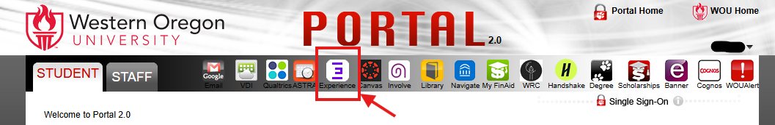

- You will start on the home tab. Click on the My Account next.
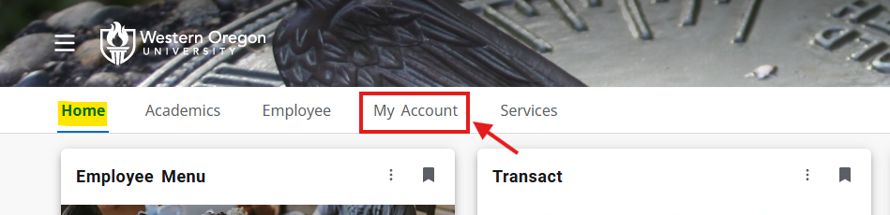

- Once in My Account, look for the card that says Proxy Management. Click on Setup Your Additional Users.
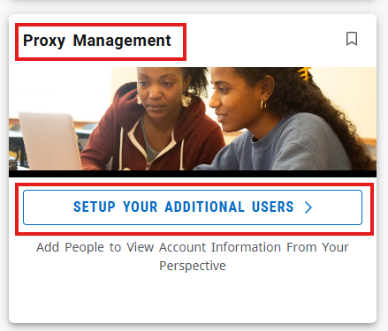

- Clicking on Setup Additional Users will open a new window called “Proxy Management”.
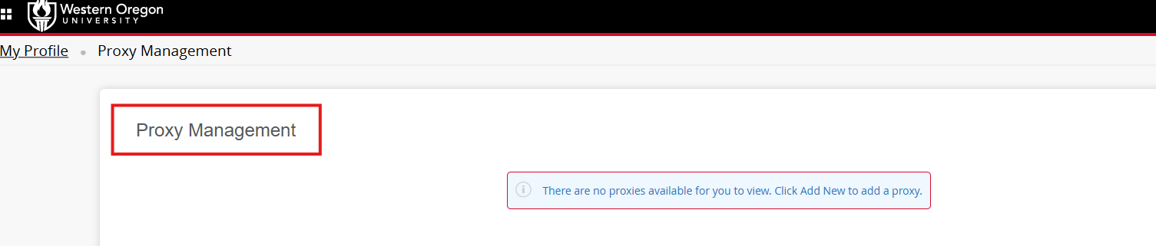

- To add a new user, click on the +Add New.
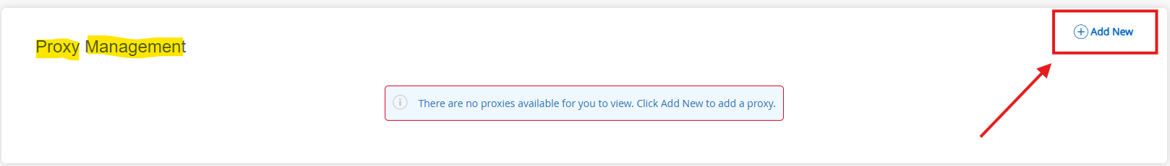

- “Proxy Information” page will pop up. Fill in all fields and create a passphrase that you and your proxy will remember.

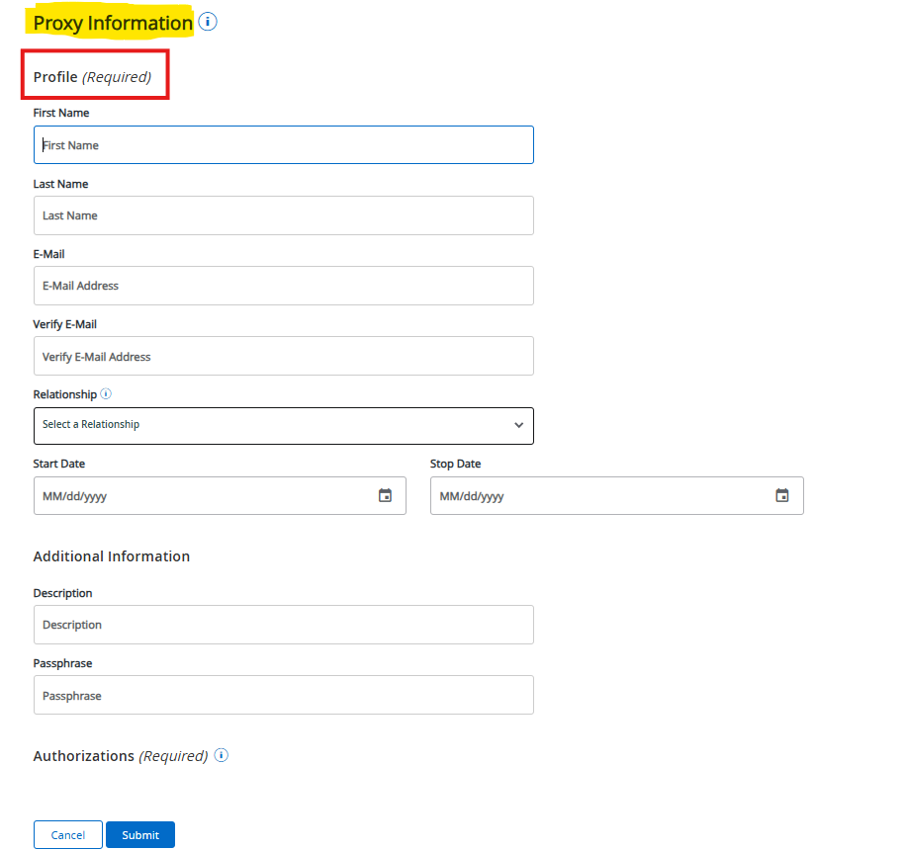

- Next, it will ask you what you want to give your proxy access to. You can select from the list or click “Select All” to give them access to everything.
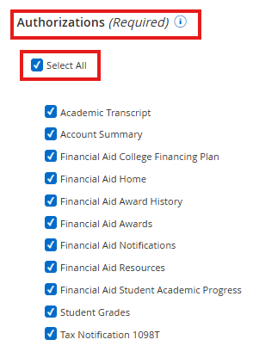

- After all fields are filled in and authorizations are selected, do not forget to click the “Submit” button.
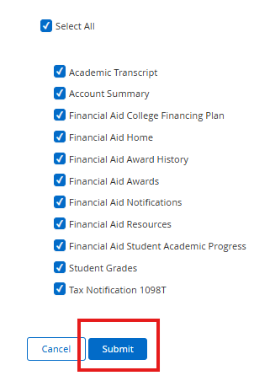
- After clicking submit, the “Proxy Management” page will pop up again. However, this time you should see the person you just added.
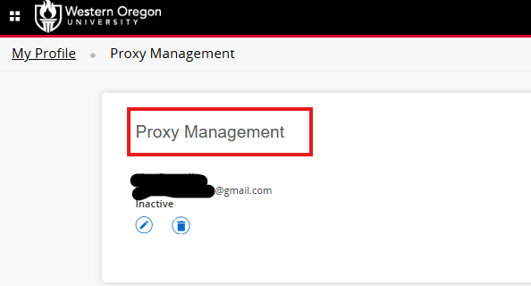

- From the “Proxy Management” page, you can edit your proxy or delete the person entirely.
